Evidence of bifunctionality of carbons and single metal atoms in
catalyzed acetylene hydrochlorination

Vera Giulimondi¹, Andrea Ruiz-Ferrando², Georgios Giannakakis¹, Ivan Surin¹, Mikhail Agrachev¹, Gunnar Jeschke¹, Frank Krumeich¹, Núria López², Adam H. Clark³, J. Pérez-Ramírez¹*
¹Department of Chemistry and Applied Biosciences, ETH Zurich, 8093 Zurich, Switzerland
²Institute of Chemical Research of Catalonia (ICIQ-CERCA), 43007 Tarragona, Spain
³Paul Scherrer Institute, 5232, Villigen, Switzerland
*jpr@chem.ethz.ch

Introduction
The manufacture of vinyl chloride (>40 Mton y⁻¹) via acetylene hydrochlorination relies on toxic carbon-supported HgCl₂ catalysts.¹ In the past decades, more sustainable metal-based alternatives were identified, sharing carbon supports as an integral component. Despite this, the metal has been traditionally considered to be the sole active site, prompting its nanostructuring to atomic level in promising single-atom catalysts (SACs).^{1,2} Still, carbon’s potential co-catalytic role remains an elusive possibility yet to be unequivocally verified. Here, we evidence the bifunctionality of carbon and single metal atoms in catalyzing acetylene hydrochlorination, by devising a multi-technique approach to monitor their structure from synthesis to operation.³

Materials and Methods
This work focuses on Pt SACs, owing to their unparalleled high and stable performance.² Operando X-ray absorption spectroscopy (XAS) enables to resolve metal sites' oxidation and coordination states from synthesis to operation. Parallely, the chemical state of surface species, e.g., carbon functionalities, is evaluated by X-ray photoelectron spectroscopy (XPS). Combination with C₂H₂ sorption and kinetic analyses permits to gain insights into the catalytic function of carbons. Guided by experiments, density functional theory (DFT) simulations further elucidate the active structure and reaction profile. The location of coke formation is investigated by electron paramagnetic spectroscopy (EPR).

Results and Discussion
Metal atoms derived following distinct synthetic procedures undergo similar dynamic behavior despite exhibiting dissimilar catalytic performance. Unlike reported mechanisms, metal atoms exclusively activate HCl (Figure 1a). We show that synthetically-induced modifications to the carbon matrix play a key role, and identify the co-catalytic function of metal-neighboring sites in the support in binding C₂H₂ by combining XPS, sorption, and kinetic analyses (Figure 1b). Such bifunctional behavior is observed across different metals and carbons, suggesting a general mechanism. Guided by the resolution of the working metal atoms’ coordination environment by operando XAS, DFT simulations rationalize C₂H₂ adsorption on a range of potential neighboring carbon functionalities rather than on the chlorinated metal atoms (Figure 1c). Finally, the leading deactivation pathway is identified in the coking of metal-neighboring sites in the carbon (ca. 5 Å, Figure 1d), by EPR.
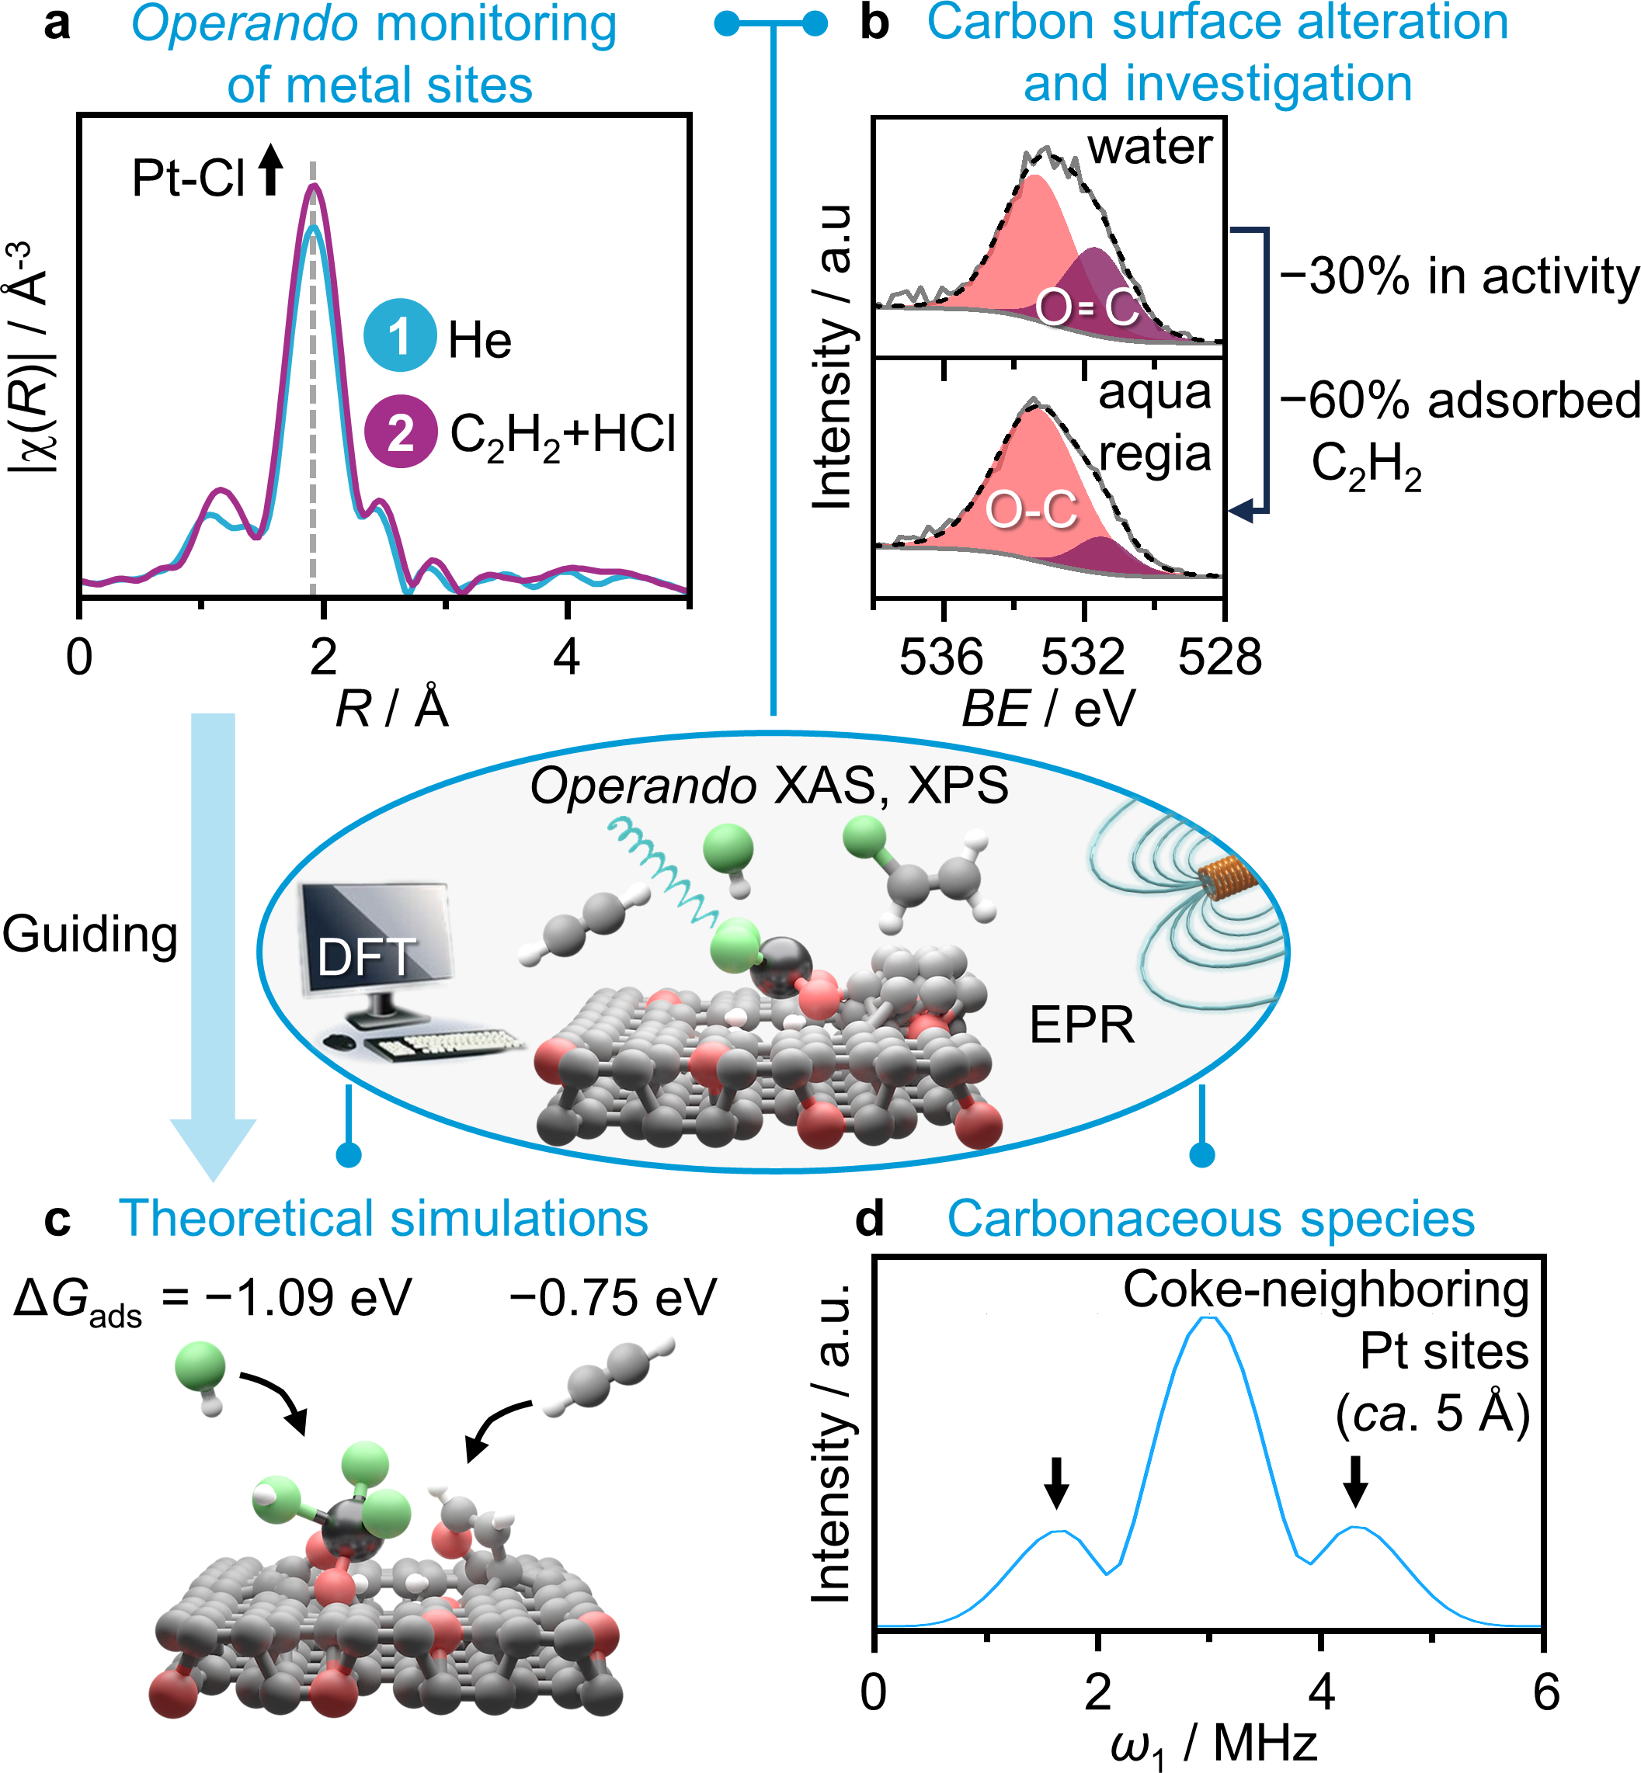
Figure 1. Schematic of the multi-technique approach employed. (a) Operando Pt L₃ edge EXAFS. (b) O 1s XPS spectra of the carbon following distinct synthetic procedures. (c) DFT simulations encompassing metal and neighboring carbon sites. (d) EPR analysis of coke deposits.

Significance
Our results expand current definitions of single-atom catalysis by evidencing that active structures can comprise ensembles of metal atoms and neighboring sites in the support. Henceforth, this presentation discusses how leveraging their individual structure and catalytic function enables to meet industrial productivity requirements.

References
- P. Johnston, N. Carthey, G.J. Hutchings, J. Am. Chem. Soc. 2015, 137, 14548.
- S.K. Kaiser, E. Fako, G. Manzocchi, F. Krumeich, R. Hauert, A.H. Clark, O.V. Safonova, N. López, J. Pérez-Ramírez, Nat. Catal. 2020, 3, 376.
- V. Giulimondi, A. Ruiz-Ferrando, G. Giannakakis, I. Surin, M. Agrachev, G. Jeschke, F. Krumeich, N. López, A.H. Clark, J. Pérez-Ramírez, Nat. Commun. 2023, 14, 5557.

